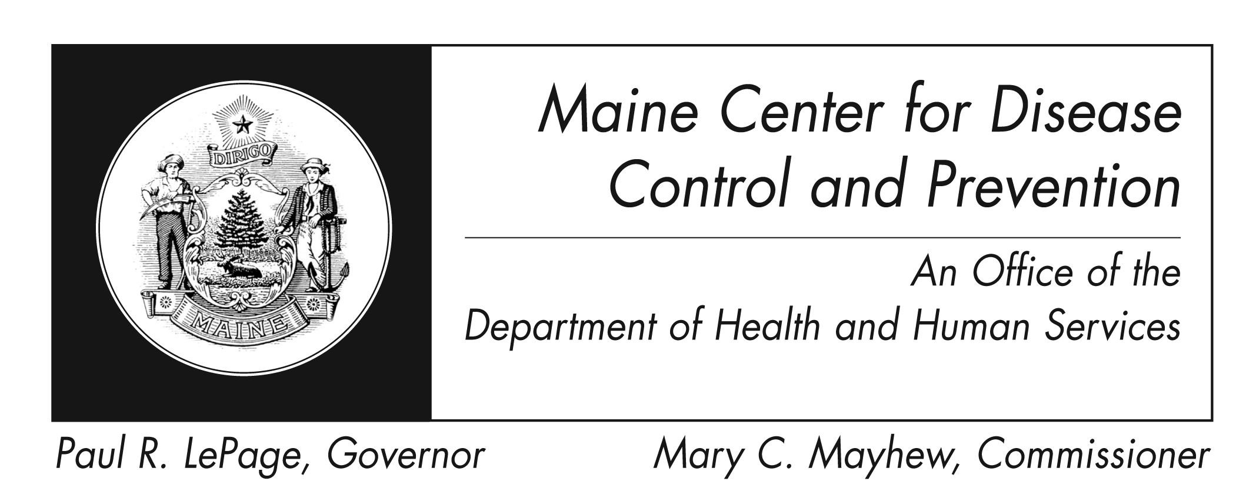
Head Lice (Pediculosis)
Fact Sheet

What are Head Lice?
The head louse, or Pediculus humanus capitis, is a parasitic insect that can be found on the head, eyebrows, and eyelashes of people. Head lice feed on human blood several times a day and live close to the human scalp. Head lice are not known to spread disease.

Forms of Head Lice
- Egg/Nit: Nits are lice eggs, laid at the base of the hair shaft, nearest the scalp. Nits are firmly attached to the hair shaft, are very small, and are hard to see.
- Nymph: An immature louse that hatches from the nit. It looks like a small version of the adult louse. Nymphs mature in 9-12 days and require blood meals to survive.
- Adult: The fully grown adult is about the size of a sesame seed, has six legs, and is tan to grayish-white. The adult can live about 30 days on a person’s head, but will die within a day or two if it falls off a person. An adult female can lay about six eggs a day.

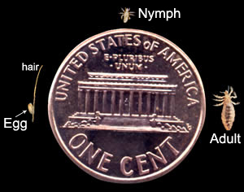
Actual size of the three lice forms compared to a penny. (CDC Photo)

How are Head Lice spread?
Head lice are spread by direct contact with the hair of an affected person. Spread by contact with combs, brushes or hats is uncommon, but can happen. Head lice cannot hop, jump, or fly, they move by crawling.

What are the signs and symptoms of Head Lice?
- Tickling feeling of something moving in hair.
- Itching, caused by an allergic reaction to the bites of the head louse.
- Irritability and difficulty sleeping; head lice are most active in the dark.
- Sores on the head caused by scratching. These sores can sometimes become infected with bacteria found on the person’s skin.

How will I know if I have Head Lice?
The diagnosis of a head lice infestation is best made by finding a live nymph or adult louse on the scalp or hair of a person. Finding nits within ¼ inch of the base of the hair strongly suggests but does not confirm an infestation. The diagnosis is best made by someone trained to identify live head lice. Dandruff, debris, and hairspray residue can be mistaken for lice eggs by someone who is inexperienced with lice.

How are Head Lice treated?
Only active infestations are recommended for treatment.

General Guidelines for Treatment
All household members and other close contacts of an infested individual should be checked for infestations. All infested persons should be treated at the same time.

Three types of treatment are available:
- Mechanical removal. This method is time consuming but effective. An infestation may be eliminated by combing each day to remove the live lice, until no live lice are discovered for about two weeks. A louse or nit comb should be used, and should be cleaned frequently to remove any caught lice or eggs.
  - Divide the hair into sections, and go through each section from scalp to the end of the hair.
  - Manually search for nits attached to the hair, and use comb to remove. If the comb cannot remove, the entire hair may be snipped.
  - Search for live lice, this may be difficult as they are small and move quickly.

- Over the counter (OTC) treatments (Pyrethrins or Permethrin). These treatments can be effective, but must be used according to the specific directions. These treatments are considered pesticides, so they should be used with caution and only when an actual infestation is occurring. It may take several hours for the medicine to kill the lice, however if after 8-12 hours lice seem as active as before the medicine may not be working. Consult a health care provider before retreating.

Resistance to Permethrin can occur, and is more common in children who have chronic infestations. However, Permethrin is still generally the first choice of treatment.

- Prescription treatments. These treatments may be necessary if the OTC treatments have failed more than twice. These treatments are also pesticides and therefore should be used with caution.

Most over the counter and prescription treatments must be repeated after 7-9 days because they only kill live lice, they do not kill the eggs.

Supplemental Measures
- Clothing, bedding, or toys can be disinfected by machine washing and drying using the HOT cycles. Spread by contact with clothing of personal items is uncommon, so excessive cleaning is not necessary.
- Non washable items can be dry cleaned, or sealed in a plastic bag and stored for two weeks.
- Vacuum the floor and furniture, particularly where the infested person spent time. However the risk of an infestation from a louse that has detached from a person is very small, so excessive cleaning is not necessary.

Did I get lice from my pet?
No. Dogs, cats, and other pets do not play a role in the spread of human lice.

Can I prevent Head lice?
- No treatment can prevent head lice. However, since lice are spread by direct contact, avoid head to head contact, and do not share combs, brushes or hats with an already infested person.

- Personal hygiene or cleanliness has nothing to do with becoming infested with head lice.

What about work, school and daycare?
There are no recommendations for exclusion from work or daycare due to a head lice infestation. National recommendations from the American Academy of Pediatrics and the National Association of School Nurses recommend that no healthy child be excluded from school due to head lice. In Maine each school district sets its own policy regarding lice and nits. Some school districts have a “no nit” policy and some do not.

How common is Head lice?
Reliable data regarding lice infestation is not available, however an estimated 6 million to 12 million infestations occur each year in the United States among children 3 to 11 years of age. Infestations are more common in children and in Caucasians more than in any other ethnic groups.

Where can I get more information?
For more information contact your healthcare provider or local health center. You can also contact the Maine Center for Disease Control and Prevention by calling 1-800-821-5821. The federal Centers for Disease Control and Prevention website - http://www.cdc.gov – is another excellent source of health information.

References
- CDC website – http://www.cdc.gov/lice/head/index.html
Accessed 10-31-2008

- Department of Health and Human Services. Maine Center for Disease Control and Prevention – Division of Family Health. Public Health Nursing. “Guidelines for the Management of Pediculosis (Head Lice). Revised June 2008.

- Maine School Health Manual. http://www.maine.gov/education/sh/pediculosis/headlice.pdf
Accessed 10-31-2008

- Harvard School of Public Health – http://www.hsph.harvard.edu/headlice.html
Accessed 10-31-2008

